Management 390 Industry Condition Analysis

Date: Mar. 8, 15

Reading 8

The right game: use game theory to shape strategy

* Business language is full of expressions borrowed from the military and from sports
  + Some are dangerously misleading
* Business is not about winning and losing
  + Nor is it about how well play the game
* The essence of business success lies in making sure you are playing the right game
* Rule-based games
  + To every action, there is a reaction
  + The reaction is not programmed to be equal and opposite
  + To analyze how other players will react to your move, you need to play out all the reactions to their actions as far ahead as possible
* Freewheeling games
  + You cannot take away from the game more than you bring to it

## From lose-lose to win-win

* Imitation is the sincerest form of flattery
  + In business, it is often thought to be a killer compliment
* When you want to change the game, you want to change ahead
* To create a win-win situation, sometimes the best way to succeed is to let others, including your competitors do well
* Advantage of looking for win-win move
  + Because the approach is relatively unexplored, there is greater potential for finding new opportunities
  + Because others are not being forced to give up ground, they may offer less resistance to win-win moves, making them easier to implement
  + Because win-win moves don’t force other players to retaliate, the new game is more sustainable
  + Imitation of a win-win move is beneficial, not harmful
* Coopetition
  + Looking for win-win as well as win-loss opportunities

## The game of business

* The game of business all about value
  + Creating
  + Capturing
* Participant
  + All the enterprises
* The value
  + Value net
    - A schematic map designed to represent all the players in the game and interdependencies among them
* Two dimension
  + Vertical: company’s customers and suppliers
    - Resource, labour, raw materials flow
      * From supplier to company, from company to customer
    - Money flow
      * From customer to company, from company to supplier
  + Horizontal
    - Players
      * The company interacts but does not transact
      * Substitutes and complements

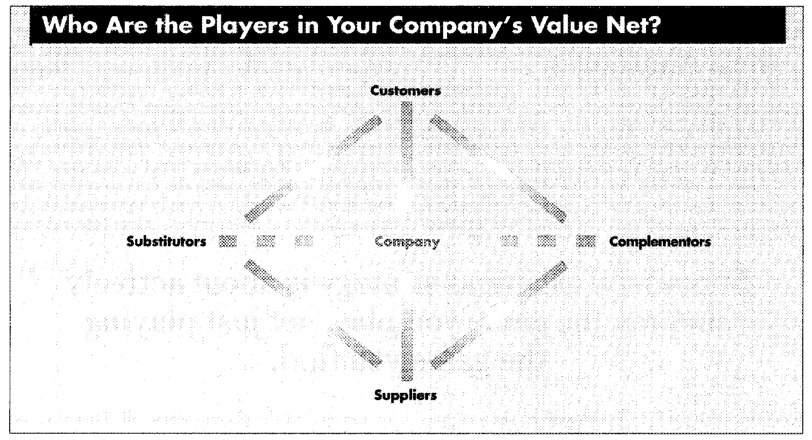

* The value Net
  + Describe the various role of the players
  + It is possible for the same player to occupy more than one role simultaneously
  + Fundamental symmetries
    - Between customers and suppliers
    - Between substitutors and complementors

## Changing the game

* The value net is a map that prompts you to explore all the interdependencies in the game
* Step to change the game
  + Drawing Value Net
  + Identifying all the elements of the game
    - Players added values
      * Each player brings to the game
      * To raise your added valuable player, there are ways to lower the added values of other players
    - Rules
      * The structure to the game
    - Tactics
      * Moves used to shape the way players perceive the game and hence how they play
    - Scope
      * Describes the boundaries of the game
      * It is possible for players to expand or shrink those boundaries
* To change the game, you have to change one of these elements

## The traps of strategy

* Changing the game is hard
* Trap
  + To think you have to accept the game you find the game is crucial
    - There is more work to be done, but more reward to be a game maker than a game taker
  + Think that changing the game must come at the expense of others
  + To believe that you have to find something to do that others cannot
  + Failing to see the whole game
  + Failing to think methodically about changing the game